M-550功率放大器M-550Power amplifier

特点：
两通道纯后级专业功率放大器，采用标准的差分放大电路，大动态输出，多种工作模式，完美的保护电路、温控无极高速风冷散热，声音动力强劲，多种灵敏度，灵活的功能选择，具有压限选择。
Two channel pure post professional amplifier .standard differential amplification circuit,large dynamic output , multiple working modes perfect protection circuit, temperature control , high speed air cooling and heat dissipation , strong voice powet,multiple sensivity and flexible function selection,with pressure limit selection Applicable places .entertainment club and Dico.Manyao bar and luxury entertainment rooms,performing arts hall,live performances,bars,mul-functiong hall,banquet hall,school,hall.

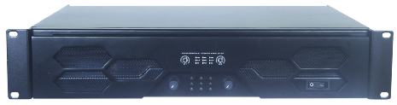

M-550
输出功率Output power：2×550W/8Ω、830W/4Ω、1660W/8Ω，，
频率响应Frequency Range:20Hz-20kHz, ±0.5dB；
灵敏度Sensitivity：0.77V
信噪比Signal-to-noise Ratio:≥95dB；
谐波失真Thd/+N: ≤0.03%；
输入阻抗Input Impeddance: 20KΩ balanced 10KΩ unbalanced ；
转换速率Conversion speed：15V/uS
隔离度Isolation：＞70 dB
冷却系统Coolig System：Automatic variable speed fan
输入电源Input Power:AC220-240V,50/60Hz；
尺寸Size：(WxDxH)482x307×88 mm；
重量：净重Net Weight12.5Kg/总重G.W:14Kg

