S-630多通道功放S-630 Power amplifier
特点：
S系列功率放大器采用了成熟经典的3级H类电路设计，简洁实用、性能稳定，具有良好的软启动系统，使功率放大器与音响系统免受电流冲击；使用了大功率高品质变压器、大容量音频专用滤波电容和大电流高耐压整流桥堆，确保了输出功率充沛强劲；带限幅器的功率输出电路，当输入电压幅度过大时，能自动将输入电压的幅度不失真压缩，避免削波波形的输出而导致扬声器因过载而烧坏；使用了两级变速风扇配合高效率的散热系统，能迅速带走功率放大器工作时产生的大量热量，完善的各种保护电路加上优秀的音质赢得了不同品位的音响师喜欢。
The series power amplifier adopts the mature and classic 3-level H-class circuit design, which is simple and practical, stable in performance, has a good soft start system, protects the power amplifier and sound system from current impact; uses high-power high-quality transformer, large-capacity audio Dedicated filter capacitor and high current high voltage rectifier bridge stack ensure sufficient output power; power output circuit with limiter can automatically compress the amplitude of input voltage without distortion when the input voltage amplitude is too large, avoiding cutting The output of the wave waveform causes the speaker to burn out due to overload; the two-stage variable speed fan is used together with the high-efficiency heat dissipation system, which can quickly take away a large amount of heat generated when the power amplifier works, and complete various protection circuits with excellent sound quality. I have won the sound of different tastes.
S-630
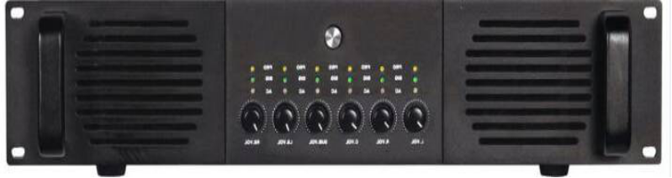
主通道输出功率Output power：8欧姆stereo power 8Ω：300W*6通，
频率响应 Frequency Range:20Hz-20kHz(+/-0.1dB) ，
谐波失真 Thd/+N:≤0.01% 8欧1/8功率 1千赫兹，
转换速度 Conversion speed：60V/us，
阻尼系数 Damping factor：350:1，
输入灵敏度InputSensitivity： 1.0V，
输入阻抗 Input Impeddance：10K Ohms-20K Ohms 不平衡or平衡Unbalanced or balanced，
输入抑制比Input rejection ratio：≤75dB，
串音Crosstalk：≤70dB，
信噪比Signal-to-noise Ratio：93dB，
面板指示灯（LED indicator）：Signal,Protect,Dctive,Clip/Liniting，
电源 power：230V,50/60Hz FUSE:T20A，
净重（Net Weight）：23Kg，
尺寸（Size(MM)：430D×483W×88H

