H-2A电源时序器
Power Timer

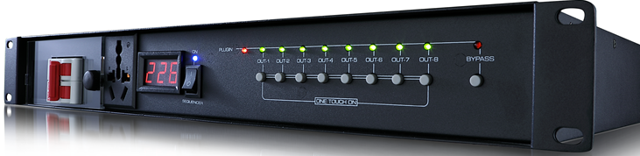
最大输入电流:80A
单路最大输出电流:30A
工作电压:220V/50-60Hz
每一路功率:可达3000W
输入与输出电压:AC输入电压=AC输出电压（下订单前请说明，可选配电压：110V输入=110V输出，220V输入=220V输出）
输出电源插座:万用插座,符合欧美标准。前面板1路直通式万用插，后面板8个受控万用插座
插座材质:每个插座材质磷铜，均通过检验才安装
每一路开关间隔时间:1秒 ，每一路带开关指示灯，前端配置一个保险开关按钮（BYPASS）
继电器:宁波松乐牌(原厂正品)
电路板线路:采用60%高纯度锡，高端分流技术,经强化加粗处理
变压器:A&C原厂正品
电源线:3*6平方的电缆线，线材配置长度为1.5米
电压显示表:有 ，（每通道可以单独受控）
机箱高度:1.5U（符合机柜按照标准）
开关:空气开关
受控功能:有 ，（每通道可以单独受控） 带232中控接口
联机支持:是，（可支持8台设备同时联机使用）联机端口：6.5米芯线插口
滤波器:电容滤波器
Maximum input current: 80A
Every channel maximum output current: 30A
Working voltage: 220V/50-60Hz
Power rate / channel: up to 3000W
Input and output voltage: AC input voltage = AC output voltage (please specify before placing the order, optional voltage: 110V input = 1010V output, 220V input = 220V output)
Output power connector : universal connector , in line with European and American standards. Front panel 1 way straight-through universal plug, rear panel 8 controlled universal socket
Socket material: Phosphorus copper for each socket material, all installed after inspection
Interval time of each switch: 1 second, each switch with indicator light, front end is equipped with a safety button (BYPASS)
Relay: Ningbo Songle brand (original authentic)
Circuit board line: 60% high purity tin, high-end shunt technology, enhanced and thickened
Transformer: A&C original authentic
Power cord: 3*6 square cable, wire configuration length is 1.5 meters
Voltage display table: Yes, (each channel can be controlled separately)
Chassis height: 1.5U (according to the cabinet according to the standard)
Switch: air switch
Controlled functions: Yes, (each channel can be controlled separately) with 232 central control interface
Online support: Yes, (supports 8 devices for simultaneous online use) Online port: 6.5 m core socket
Filter: Capacitor Filter

