H-232图示均衡器 EQUALIZER

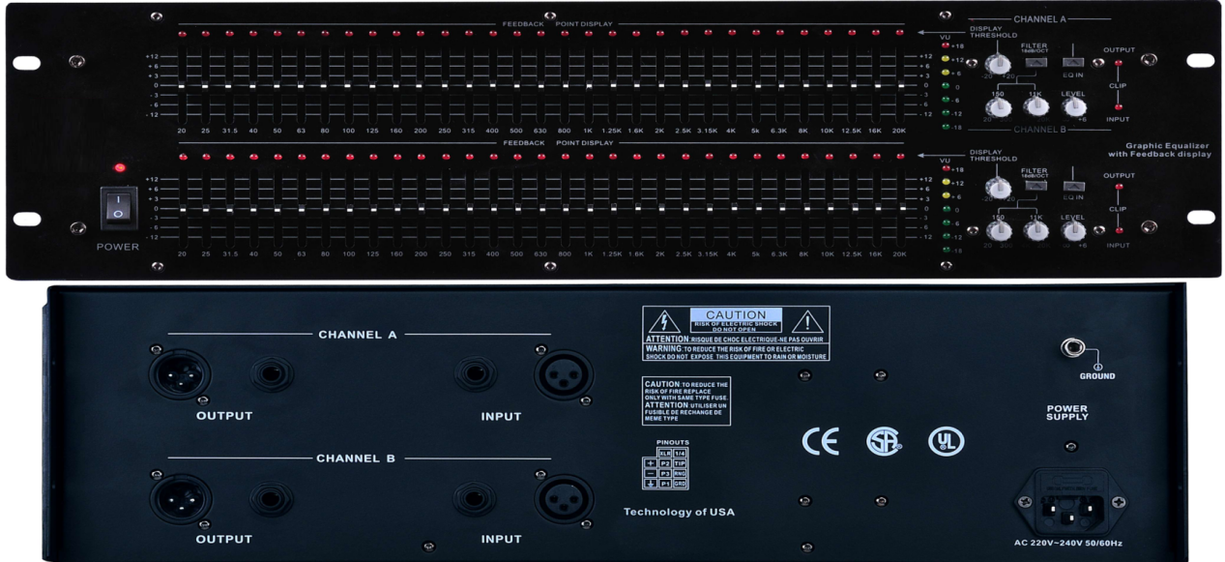

产品特点:
图示双31段恒定Q值均衡器，1/3倍频程
30mm长推杆，更加精细调节系统
全SMT表面贴装工艺
双7段光柱电平
前面板旁通开关
带反馈点检测并指示，检测灵敏度可调
高切及低切开关功能，切点频率可调
Dual 31-segment constant Q equalizer, 1/3 octave
30mm long putter, finer adjustment system
Full SMT surface mount process
Double 7-segment beam level
Front panel bypass switch
With feedback point detection and indication, the detection sensitivity is adjustable
High cut and low cut switch function, adjustable cut point frequency

