HF-2数字反馈抑制器(带矩阵编辑功能）Digital feedback Suppressor

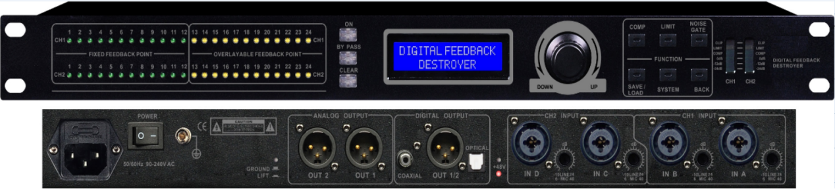
产品特点：
1、96KHz采样频率，32-bit DSP处理器，24-bit A/D及D/A转换；
2、设备内置矩阵（路由）编辑功能；
3、输入通道提供4组复合型（COMBO）音频输入接口；
4、设备可接受较宽交流电压输入，输入范围AC90～240V 50/60Hz；
5、可通过面板的BYPASS/ON按键切换工作模式为直通或抑制；
6、全自动窄带陷波式反馈抑制；
7、每通道独立1 2个固定滤波器和1 2个动态滤波器，可通过“系统”键来设定固定或动态滤波器的个数；
8、可通过面板的4 8个LED啸叫点指示灯，显示当前啸叫点个数；
9、带有压缩，限幅，噪声门功能；
10、单机提供3 0组设备数据存储，存储压缩，限幅，噪声门的参数。关机后可保存关机前的啸叫抑制状态；
11、可通过面板的“系统”键来设定密码锁定面板操作的部分或全部功能，以防止非相关人员的操作破坏机器的工作状态；
12、采用液晶屏显示设置参数；
13、6段LED精确数字电平表显示输出信号大小；
14、提供4路话筒放大输入和线路输入，带48V幻想电源；
15、提供模拟，数字AES3，光纤，同轴输出。单机可存储30组用户程序；
16、采用LCD显示屏显示功能设定144*32，提供6段led显示输出电平；
17、每通道提供压缩、限幅、噪声门、功能设置；
18、可任意编辑固定和动态反馈点数量。
96KHz sampling frequency, 32-bit DSP processor, 24-bit A/D and D/A conversion
Device built-in matrix (routing) editing function
Input channel provides 4 sets of composite (COMBO) audio input interface
The device can accept a wide AC voltage input, input range AC90 ~ 240V 50 / 60Hz
The working mode can be switched to pass through or suppressed by the BYPASS/ON button on the panel.
Fully automatic narrow band notch feedback suppression
Each channel has 12 fixed filters and 12 dynamic filters. The number of fixed or dynamic filters can be set by the “System” button.
The number of current howling points can be displayed through the panel's 4 8 LED howling indicators.
With compression, limiting, noise gate function
The single unit provides 30 sets of device data storage, storage compression, limiting, and noise gate parameters. After shutdown, you can save the howling suppression state before shutdown.
Some or all of the functions of the password lock panel operation can be set through the "System" button on the panel to prevent the operation of the unrelated personnel from damaging the working state of the machine.
LCD display setting parameters
6-segment LED accurate digital meter shows output signal size
Provides 4 channels of microphone amplification input and line input with 48V fantasy power supply
Provide analog, digital AES3, fiber optic, coaxial output. Stand-alone storage of 30 sets of user programs
Use LCD display display function setting 144*32 to provide 6-segment led display output level
Compression, clipping, noise gate, function settings per channel
The number of fixed and dynamic feedback points can be edited arbitrarily

